Dear Parents,

Here at ABC, we consider ourselves to be a big family. During the first few months of school, our themes have included “All About Me”, “Favorite Things” and “Things We Are Thankful For”.

Through these themes and various projects, we have gotten to know your child and your family a little bit, so this gives you a chance to learn about us!

But first, here is a little bit about our school:

ABC Christian is celebrating the start of it’s 19th YEAR! Wow....what a huge blessing! ABC started as a small dream with only 10 children in our first school year! It’s so hard to believe when we have had over 180 students in some years!

God has blessed us with a building to house our school, wonderful families, and sweet children. Our goal has and will always continue to be, to bring honor to God, by educating children about Him, and treating them with the utmost respect at all times. Also, to prepare them for Kindergarten, and always show them a love of learning that will last them a lifetime.

We thank you for allowing us the blessing of spending time with your children.

The ABC Christian Learning Academy Staff

We are dedicating this year to our beloved Mrs. Jenn.
We love her and will miss her every day.
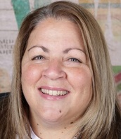
Mrs. Jenn Emch
8-16-67 to 7-19-24

Mrs. Trish

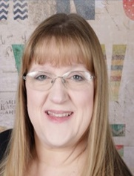
I live in Griffith. I have been married to my husband Steve for 31 years. We have a son Brandon, who is married to Jessica and they live in Crown Point, and a daughter Rebecca that is married to David and they live in Griffith. I am so in love with being a Grandma to my sweet grandsons Lucas and Grayson! I am the Administrator here at ABC which means I handle the office "stuff" but I am so lucky to be able to help out with ALL of the students every chance I get! I started the school 19 years ago and I have the BEST job in the world!

Some of my favorites....
Colors – Blue and Purple
Candy/Snacks – Salted Peanuts or Cashews, Reece’s, Twix, I LOVE Dunkin Iced Carmel Coffee with cream, and Pringles. My favorite snack is veggies with Ranch dip!
Scents – BBW Wall Flowers – Eucalyptus Spearmint Stress Relief, Clean scents like Cucumber/Citrus/Ocean/Linen
Things I collect – Willow Tree figurines, Precious Moments figurines, Organizing items, and anything a child makes!
Things to do – I love to scrapbook, and go on cruises with my husband!
Misc – Mrs. Kelli has been my best friend since we were 5 years old, and Mrs. Becca is my daughter!

My birthday is - September 27th

Things I am thankful for – God, my family, being a grandmother, and the ability to have a job that I love!

I can be contacted at: 219-688-8290 or Trish1927@aol.com

Mrs Becca

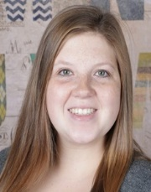
I live in Griffith with my husband David and our 2 ½ year old son Lucas and 8 month old son Grayson. We have one dog, Maggie and a cat named Bert. I have helped at ABC since it started (Mrs. Trish is my mom!!) but have officially been on staff for 10 years. I am a labor and delivery nurse, but I am working in the office even more now that I am at home with my sons.

Some of my favorites....
Colors – Teal, gray, purple and coral
Candy/Snacks – Sour Patch kids, Doritos, Jays BBQ chips, Mint gum, Starbucks Pink Drinks, Pepsi, McDonalds Coke, and I love eating at Olive Garden, Chick-Fil-A, Taco Bell, La Quesadilla, and House of Kobe.
Scents – Scentsy – Luna, Black Raspberry Vanilla BBW – Rose Water & Ivy, Sleep Black Chamomile, and Sandalwood. Essential Oils – Citrus, Calming and Sleep.
Things I collect – Wood signs and picture frames, “mom” things and anything that says Momma on it!
Things to do – Watching Friends, Greys Anatomy, hanging out with my sons, taking walks to my parents house, and going to Target!

My birthday is - May 16th

Things I am thankful for: My family and my animals

I can be contacted at: BeccaBradyABC@gmail.com or 219-689-5832
Mrs. Kelli
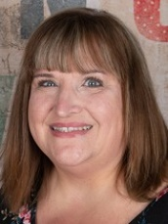
I live in Hobart with my husband Jerry. We have three kids – Ryan, Jonah, and Morgan who are all grown. I have two little dogs Giovanni and Finn. I am one of the Head Preschool Teachers! This is my 18th year at ABC!

Some of my favorites....
Colors – Purple and Gray
Candy/Snacks – Wintergreen Life Savers Mints and Gum, and Chips and Salsa
Scents – Gardenia, clean scents and stress relief
Things I collect – Willow Tree Figurines, Beach Glass, Christmas Ornaments and Disney Ornaments
Things to do – I love to travel – especially on Cruises, and trips to Disney. I also enjoy reading and walking my dogs.

My birthday is - July 12th

Things I am thankful for: My family and friends

I can be contacted at: Kellith522@aol.com 219-801-2566

Mrs. Kristina
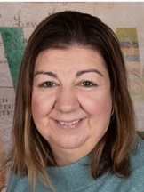
I live in Schererville with my husband Shawn, my three boys: Sam 16, Ben 13, Eli 11, and my brother who is disabled. This is my 7th year at ABC and I am one of the Head Preschool teachers. I was an ABC mom previous to teaching!

Some of my favorites....
Colors – Teal, Gray, and Blue
Candy/Snacks – Chai Tea, Chocolate, Cool Ranch Doritos, and Jr. Mints
Scents – Natural and Fall Scents (nothing flowery)
Things I collect – I love wood signs!
Things to do – Anything with my family.

My birthday is - August 13th

Things I am thankful for:
I am thankful for my family and my friends, and that they are all healthy.

I can be contacted at: mekocamp@yahoo.com or 219-669-3307

Mrs. Aimee
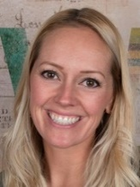
I live in Schererville with my husband Tim, and my twin daughters Brooklyn and Jensen who are in 4th grade! This is my 5th year as a staff member at ABC (but I was an ABC Mom prior to that). I am the Head Teacher of the Four All Day Pre-Kindergarten class.

Some of my favorites....
Colors – Blues, Grays, CAMO and GLITTER!!!!
Candy/Snacks – Reese’s Pieces, Swedish Fish, Peanut M&Ms, Mint Gum, Combos (Pretzel Cheddar), Veggies or Fruit with Dip, and Cinnamon Sugar Bagels
Scents – Coconuts/Tropical and Holiday Scents
Things I collect – Picture frames, and Monogram “D” items
Things to do – Travel with family, baking, playing or watching sports, working out, and DIY crafting!
Misc – I love SEUSS!!!

My birthday is - February 11th

Things I am thankful for: my family, my health and my freedom!

I can be contacted at: MrsAimeeABC@gmail.com

Mrs. Elaine
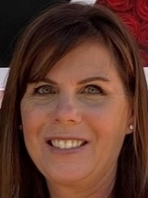
I live in St John with my husband Jim. We have three sons-Tom, Matthew and Jason, plus two daughter-in-laws Alisha and Kah Yee, as well as our grandson Benjamin. This is my 2nd year at ABC. I am the Head Teacher of the Morning Pre-Kindergarten class.

Some of my favorites....
Colors – Black
Candy/Snacks – Dark chocolate, coffee and pizza!
Scents – Lavendar
Things to do – My favorite activity is spending time with my kids and husband. We love to hike, swim and cook together. When I have free time I like to read. I have two cats, so I picked Pete the Cat for our classroom theme!

My birthday is – May 18th

Things I am thankful for:
My family and finding a great place to teach – ABC!

I can be contacted at: ElaineFouss@gmail.com or 740-277-8489

Mrs. Missy
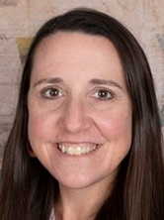
I live in St John with my husband Todd, my son Chase who is 11 and in 6th grade, and my daughter Sophie who is 9 and in 4th grade. This is my 6th year as a staff member at ABC and I am one of the Head teachers in the Three All Day Pre-Kindergarten classes! Before that I was an ABC Mom for 4 years.

Some of my favorites....
Colors – Orange and Blue
Candy/Snacks – Swedish Fish, Strong Coffee (Starbucks), Mint gum, Chocolate Chip Cookies, Poppables chips, Watermelon Ice Breakers, and all breakfast food including cereal.
Things I collect – Artwork from local artists of places that we visit
Things to do – I like running, reading, skiing, painting with watercolors, hiking, playing games with my kids (especially Euchre), and I love music.

My birthday is - November 7th

Things I am thankful for: Health, family, friends and Jesus!

I can be contacted at: Anderson.ma117@gmail.com or 773-504-3474

Mrs. Brandi
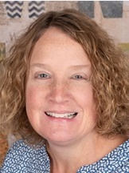
I live in St John with my husband John. We have been married for 24 years and we have two sons, Brian (23) and Trevor (20), and one dog Harper (6 months). This is my 14th year at ABC. I taught Preschool for 10 years, and this is my 4th year as a Head Teacher in the Three All Day Pre-Kindergarten classes. Before that I was an ABC Mom!

Some of my favorites....
Colors – Blue
Candy/Snacks – Reese’s Peanut Butter Cups, Pringles, Guacamole/Chips, Skinny Pop, Bottle Caps, Coffee, Frappuccinos, Chobani Mango, Salt & Vinegar Poppables, Pictachios and Sweet Tea!. I like going to Dunkin, Starbucks, Target, Kohl’s, and shopping on Amazon. Mexican food is my favorite!
Scents – Clean and Fruit scented candles, BBW – Hello Beautiful, Flowery and Gingham Scents
Things I collect – Willow Tree Angles
Things to do – I like spending time with my family, pool and beach time!

My birthday is - November 11th

Things I am thankful for: my Family and Friends.

I can be contacted at: MrsBrandiABC@gmail.com

Mrs. Leslie
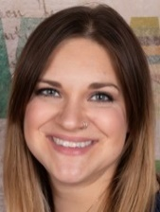
I live in Cedar Lake with my husband Jon, and sons Gavin and Ian. We have two dogs - Moxie and Demi, a two cats – Storm and Cinder. This is my 6th year at ABC! I am one of the Head teachers in the Three All Day Pre-Kindergarten classes. Before working here, I was an ABC Mom!

Some of my favorites....
Colors – Green, Blue, Purple or anything tie-die or leopard print!
Candy/Snacks – Starbucks, Dunkin, Speariment gum, and Ferraro Roche
Scents – Anything floral, water/outdoor, and fruity scents. Nothing baked.
Things I collect – Llamas, Jellyfish, I Love Lucy, New Girl, and Friends

My birthday is - May 14th

Things I am thankful for: My village – my family, friends and ABC Co-workers

I can be contacted at: MrsLeslie.abc@gmail.com or on the Group Me app

Mrs. Brenda
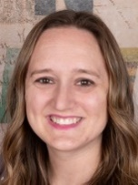
I live in Cedar Lake with my husband Bill, and daughters Natalie and Haylie. This is my 4th year at ABC! I am one of the Head Teachers in the Three All Day Pre-Kindergarten classes.

Some of my favorites....
Colors – Pink, Purple and Teal
Candy/Snacks – M&M’s, Sour Patch, 3 Musketeers, Mike & Ike, Extra Mint Chocolate Chip, Kettle chips, Lays Stax, White Cheddar Doritos, and anything Gluten Free because I have Celiac!
Scents –Fruity, Lavender, Gingham and Thousand Wishes
Things I collect – Animal print and anything personalized!
Things to do – Hang out with my girls, watch movies, go on roller coasters, scrapbook, take pictures, crochet and teach of course!

My birthday is - December 18th

Things I am thankful for: Family and Friends, Health and Happiness!

I can be contacted at: Brenda8308@gmail.com or Group Me App

Mrs. Wendy
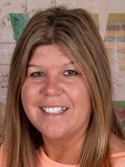
I live in St John with my husband Jeff, son Jeff Jr, (15) and daughter Gianna (13). My mom Ms. Ducky lives with us as well! I am an Assistant in the Preschool Classrooms! This is my 9th year at ABC on staff, but I was an ABC Mom for 5 years before that!

Some of my favorites....
Colors – Pink, Purple, Yellow and Teal
Candy/Snacks – Twix, Reese peanut butter cups, Nacho Doritos, Fritos, Skinny Pop, Hershey Kisses, Muncho’s, Glazed donuts and Chocolate chip muffins from DD.
Scents – I like all scents except flowery scents. My favorite BBW scent is called “Rose” (yeah I know….but I doesn’t smell flowery)
Things I collect – Signs with sayings on them
Things to do – Anything with my kids! Especially watching them play sports. I like baseball, softball and basketball.

My birthday is - March 19th

Things I am thankful for: My family

I can be contacted at: WendyT1717@yahoo.com or 708-935-4853

Ms. Ducky (Patti)
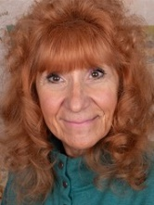
I live in St John with my daughter and her family in what I like to call “Ducky’s Den” in the basement of her home! I have a son, and a daughter - Mrs. Wendy! I have 6 Grandchildren and 2 Great-Grandchildren. I am one of the Preschool Class Assistants! This is my 8th year at ABC!

Some of my favorites....
Colors – Yellow, Red and Teal
Candy/Snacks – All chocolate! Especially Hershey bars, Hershey kisses, Reeses, Doritos, Chili Cheese Fritos, Smoothie King and Dunkin coffee!
Scents – I don’t like flower scents, but I like Pumpkin Spice, Vanilla, and Warm Fall or Winter Scents.
Things I collect – Owls and Snowmen
Things to do – I like bowling, baking, watching my grandchildren play sports, and ride my bike or go on walks.

My birthday is - September 10th

Things I am thankful for: I am thankful for my family, wonderful friends, and my job at ABC

I can be contacted at: CherryBomb910@yahoo.com or 708-743-3630

Mrs. Tiffany
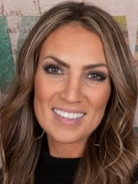
I live in Dyer with my husband Shea and our three wild boys – Gavin (9), Hudson (7), and Kayden (4)! As a family of 5, my heart couldn’t be more full! I am one of the Pre-Kindergarten Class Assistants! This is my 4th year on staff at ABC, but I have been an ABC Mom for 3 years prior to that! I am really excited for this year as my youngest, Kayden will be a student in Mrs. Elaine’s Morning Pre-K class!

Some of my favorites....
Colors – Muted colors – tan, white, mauve and black, and olive green
Candy/Snacks –M&M’s are my favorite, but I also like Laffy Taffy, Jolly Rancher Fruit Chews, Life Saver Mints, Minty Gum, Hippeas Check Pea Puffs-Nacho Vibes, Ranch Veggie Straws, Dots Pretzels, Boom Chicka Pop – Kettle Popcorn, Starbucks and Dunkin.
Scents – White Magnolia, Eucalyptus, and Fresh Linen
Things I like – Candles, Throw Blankets, Dry Wines, and Hockey Mom Stuff!
Things to do – I enjoy spending time with my kids! I’m a hockey, football, baseball and basketball mom. I love to work out when I have time and I like to decorate my home.

My birthday is - September 9th

Things I am thankful for: I am thankful for my family, friends, and that I can work at such an amazing school.

I can be contacted at: Evans.Tiffany39@gmail.com or 270-304-7740

Mrs. Michelle
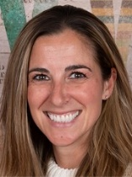
I live in Cedar Lake with my husband Andy and our two daughters Mila 8 and Vivienne 6. I am one of the Pre-Kindergarten Class Assistants! This is my 4th year on staff at ABC, but was an ABC Mom for 4 years before that!

Some of my favorites....
Colors – Mauve and Olive Green
Candy/Snacks –Reese peanut butter cups, Mint gum, Sun chips / baked Lays, Caramel coffee – Starbucks/Dunkin – coffee is my fav!!! Cheese and crackers, bagels and muffins.
Scents – Holiday and season scents
Things I collect – coffee mugs and tumblers
Things to do –Travel or hang out with my family and friends, shop, go for walks, go to the beach, go to Target!

My birthday is - December 21st

Things I am thankful for: My family, friends and working here at ABC!

I can be contacted at: MichelleLoomis12112@yahoo.com 219-796-7079

Mrs. Kim
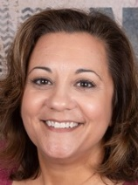
I live in Schererville with my husband Jerry and our 11 year old daughter Emma. I am one of the Assistants in the Pre-Kindergarten classes. This is my 7th year at ABC as a staff member, but I was an ABC Mom for 2 years before that!

Some of my favorites....
Colors – Purple, Blue, and Gray
Candy/Snacks – Reese peanut butter cups, Poppables, Nutterbutters, Unsweet Iced Tea, Starbucks and Dunkin
Scents – Scentsy sweet scents
Things I collect – Anything Disney
Things to do – Travel with family and friends, hangout with friends, and play with my puppy!

My birthday is - June 6th

Things I am thankful for: My family and friends, and a job I enjoy with my ABC Family.

I can be contacted at: Kimber0606@yahoo.com 708-565-0606

Mrs. Veronica

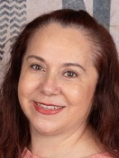
I live in St John with my husband Memo and our son Jesse. I am one of the Assistants in the Pre-Kindergarten classes. This is my 5th year at ABC as a staff member, but I was an ABC Mom for 2 years before that!

Some of my favorites....
Colors – Red, Blue, Green
Candy/Snacks – Frape Mocha Coffee, Pancakes and any kind of chips
Scents –Lavender and Pear Essence
Things I like/collect – Dolphin figures, Angels, making crafts, painting, and weaving.

My birthday is - August 2nd

Things I am thankful for: my family and my job. I have co-workers that are so kind to me and I appreciate them very much.

I can be contacted at: 219-888-8283
Mrs. Christy
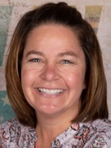
I live in Cedar Lake with my husband Geoff and our daughter Megan (14) and our son Geoffrey (12). I am one of the Assistants in the Pre-Kindergarten classes. This is my 5th year at ABC!

Some of my favorites....
Colors – Blue
Candy/Snacks – M&M’s, Chocolate covered pretzels, and I love all kinds of popcorn. I drink Green Tea in the morning.
Scents – BBW hand soaps, shower gels and lotions in Apple or Tropical scents.
Things to do – Watch my daughter cheer for Hanover High School, and root for my son playing football for Hanover Jr Wildcats.

My birthday is - July 31st

Things I am thankful for: My friends and family

I can be contacted at: ChristyMCFarland@icloud.com or 708-439-5017

Mrs. Laura
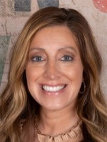
I live in Schererville with my husband Dustin and our son Tyler (11), and daughter Madison (10). I am one of the Assistants in the Pre-Kindergarten classes. This is my 5th year at ABC!

Some of my favorites....
Colors – Pink and Teal
Candy/Snacks – Twizzlers cherry bites, Mentos gum, Coconut mocha coffee k-cups, Cliff Bars – peanut butter.
Scents – I love all Fall scents especially Harvest candle, Coconut for body sprays, and White T-shirt for hand soaps.
Things I collect – cute coffee tumblers and seasonal decor
Things to do – I love traveling, going for walks, and bike riding.

My birthday is - January 5th

Things I am thankful for: my family, my job working with preschoolers, and I don’t think I could have found a better work family than ABC!

I can be contacted at: Laura.C.Oakes@gmail.com or 219-688-6705

